HCL-TASKS
Github link:
https://github.com/Suriya-MD/HCL-Automation-Testing/
Task-01:
Code:
import time
from selenium import webdriver
from selenium.webdriver.common.by import By
from selenium.webdriver.support import expected_conditions as EC
from selenium.webdriver.support.ui import WebDriverWait

driver = webdriver.Chrome()
wait = WebDriverWait(driver, 10)

# TC01: Open page using get() and verify using XPath
driver.get("https://demoqa.com/automation-practice-form")
time.sleep(3) # Pause to let the page load

header = wait.until(
EC.visibility_of_element_located((
By.XPATH,
"//h1[text()='Practice Form'] | //div[text()='Practice Form']",
))
)
time.sleep(4) # Pause to view verified page

print(f"✓ TC01 Passed: {header.text}")

Output:
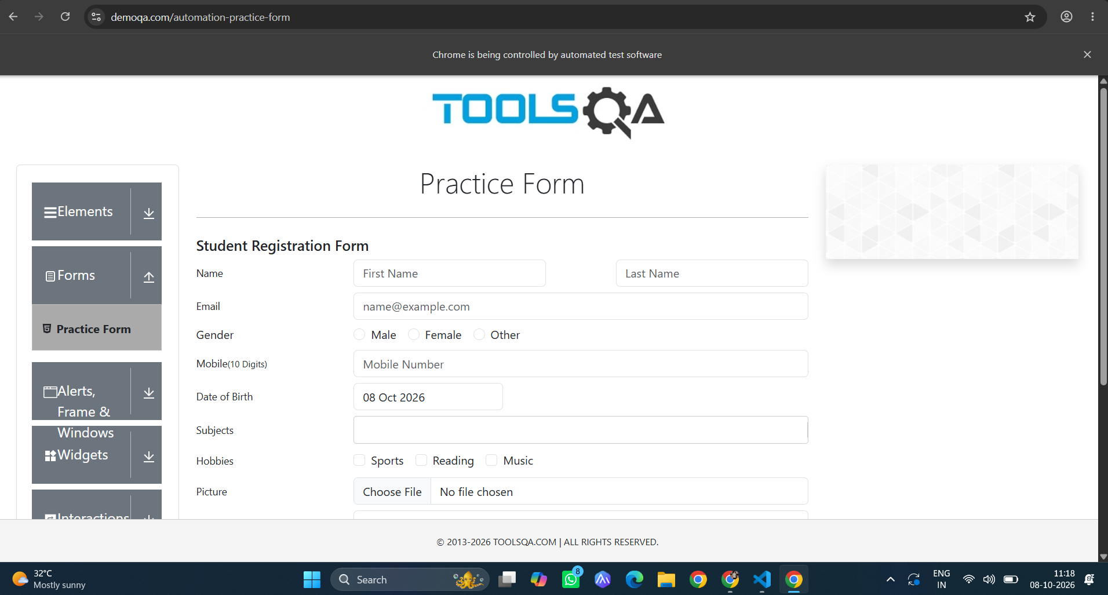

Task2:
Code:

import time
from selenium import webdriver
from selenium.webdriver.common.by import By
from selenium.webdriver.support.ui import WebDriverWait
from selenium.webdriver.support import expected_conditions as EC

driver = webdriver.Chrome()
wait = WebDriverWait(driver, 10)

1. Open the page
driver.get("https://demoqa.com/automation-practice-form")
time.sleep(3)

2. TC02: Locate First Name using Attribute XPath [@id='firstName']
first_name = wait.until(EC.visibility_of_element_located((By.XPATH, "//input[@id='firstName']")))
first_name.send_keys("Swaminathan")
time.sleep(2)

3. Locate Last Name using Attribute XPath [@id='lastName']
last_name = driver.find_element(By.XPATH, "//input[@id='lastName']")
last_name.send_keys("V")
time.sleep(2)

print("✓ TC02 Passed: Username fields located using Attribute XPath")

Output:
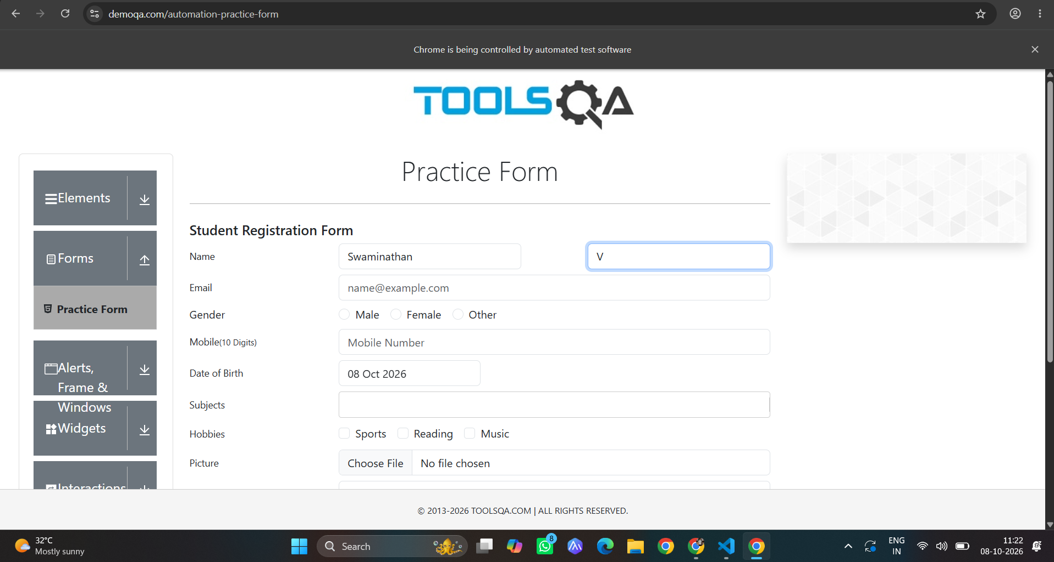

Task-3:
Code:
import time
from selenium import webdriver
from selenium.webdriver.common.by import By
from selenium.webdriver.support import expected_conditions as EC
from selenium.webdriver.support.ui import WebDriverWait

driver = webdriver.Chrome()
wait = WebDriverWait(driver, 10)

# 1. Open DemoQA Login Page
driver.get("https://demoqa.com/login")
time.sleep(3)

# 2. Locate Username via Attribute XPath
wait.until(
EC.visibility_of_element_located((By.XPATH, "//input[@id='userName']"))
).send_keys("testuser")
time.sleep(2)

# 3. Task: Locate & Enter Password using Attribute XPath [@id='password']
password_field = driver.find_element(
By.XPATH, "//input[@id='password' and @type='password']"
)
password_field.send_keys("SecretPassword123!")
time.sleep(2)

print("✓ TC03 Passed: Password entered using Attribute XPath")

Output:
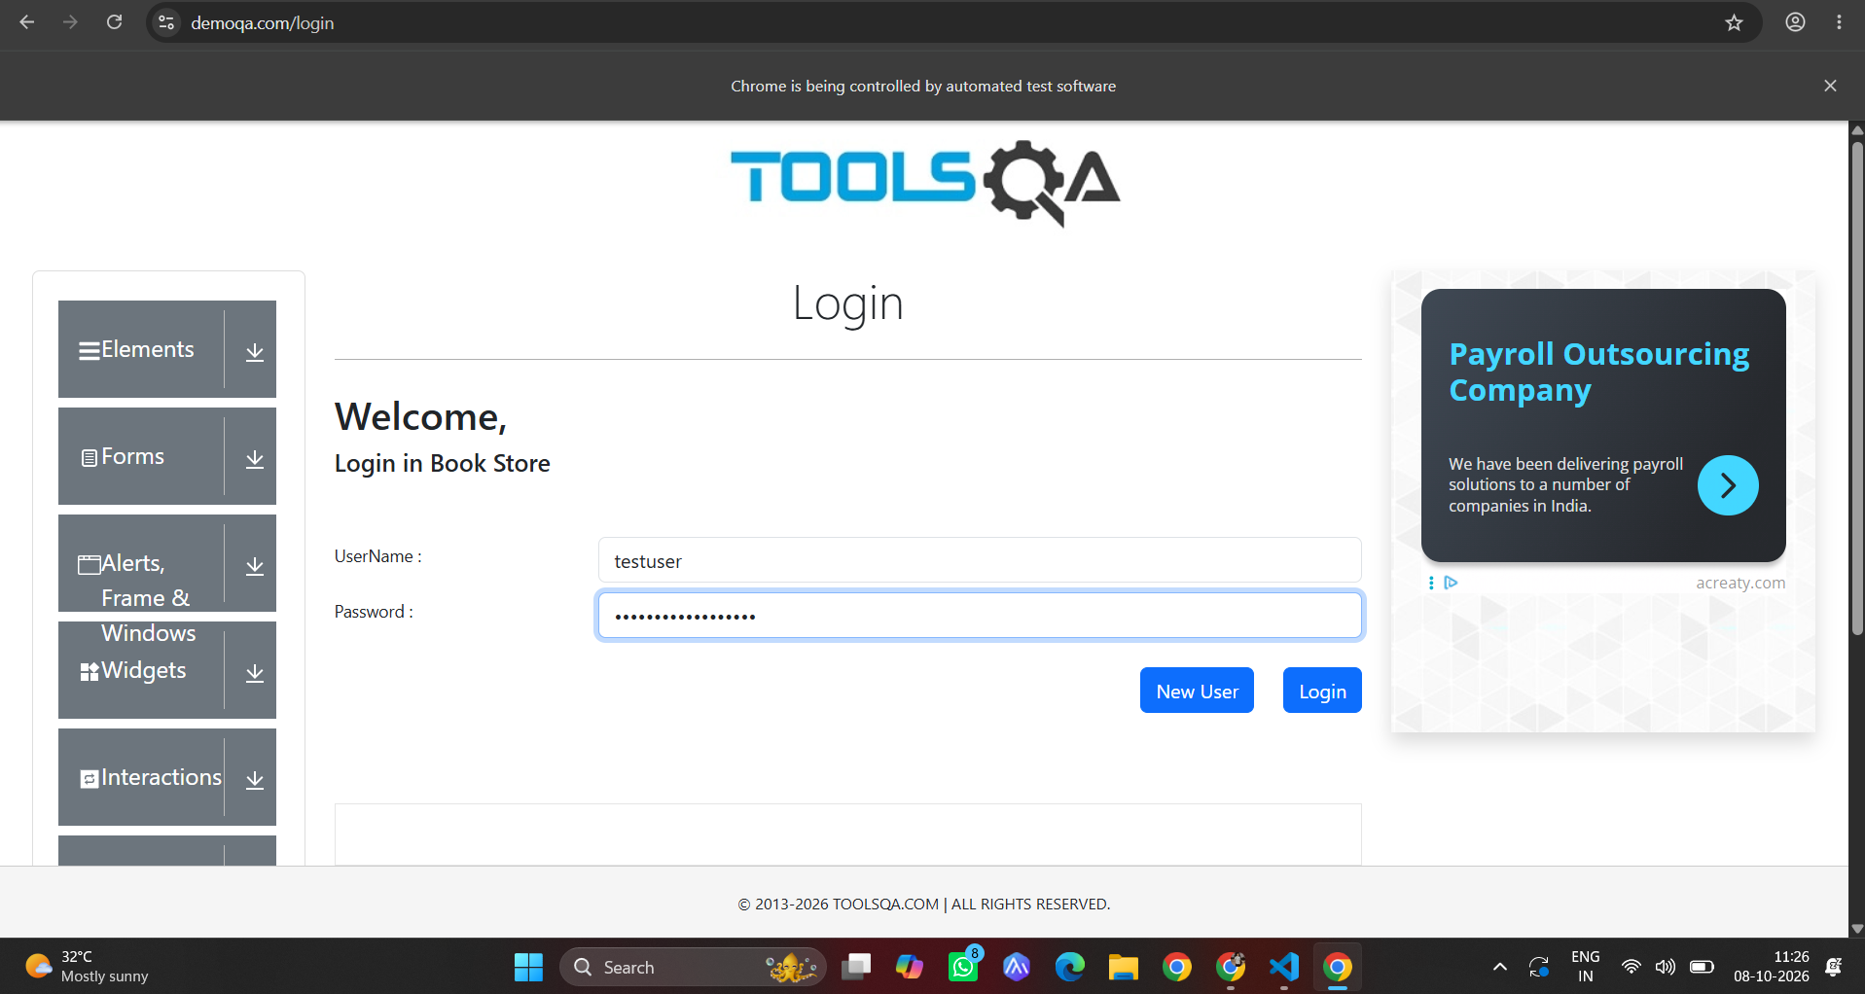

Task-04:
Code:

import time
from selenium import webdriver
from selenium.webdriver.common.by import By
from selenium.webdriver.support.ui import WebDriverWait
from selenium.webdriver.support import expected_conditions as EC

driver = webdriver.Chrome()
wait = WebDriverWait(driver, 10)

# Open page
driver.get("https://demoqa.com/automation-practice-form")
time.sleep(3)

# TC04: Locate Submit button using text() method
# Note: On this form, scrolling or using a JS click prevents ad overlays from blocking the button
submit_btn = wait.until(
EC.presence_of_element_located((By.XPATH, "//button[text()='Submit']"))
)
driver.execute_script("arguments[0].scrollIntoView(true);", submit_btn)
time.sleep(2)

driver.execute_script("arguments[0].click();", submit_btn)
time.sleep(2)

print("✓ TC04 Passed: Submit button located using text() XPath")

Output:
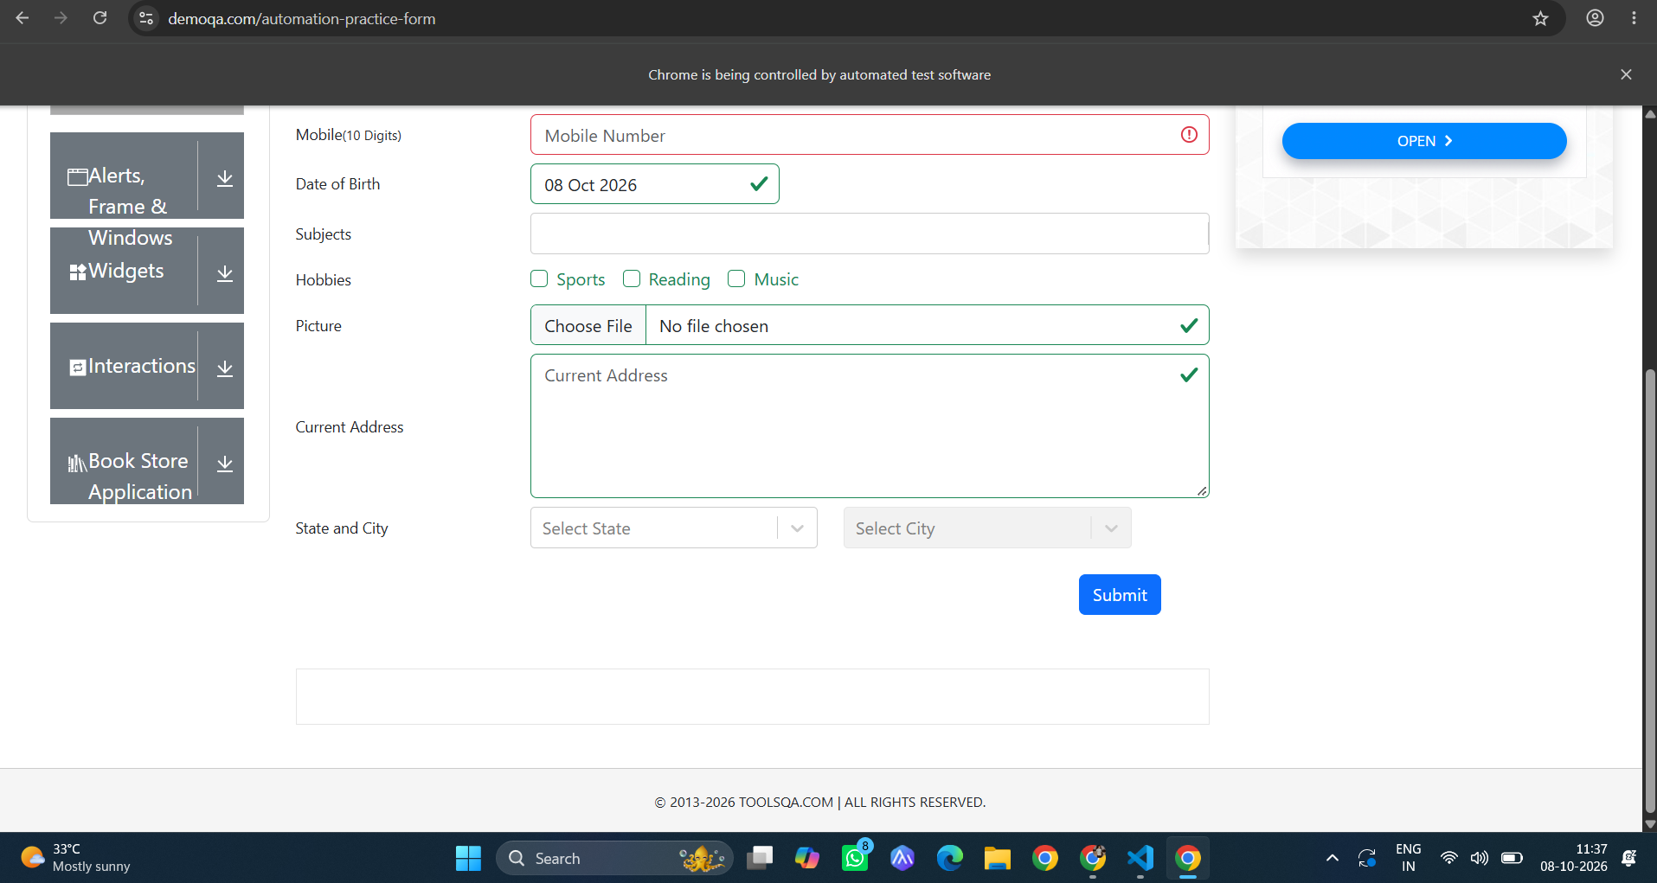

Task-05:
Code:
import time
from selenium import webdriver
from selenium.webdriver.common.by import By
from selenium.webdriver.support.ui import WebDriverWait
from selenium.webdriver.support import expected_conditions as EC

driver = webdriver.Chrome()
wait = WebDriverWait(driver, 10)

# Open page
driver.get("https://demoqa.com/automation-practice-form")
time.sleep(3)

# TC06: Locate element using starts-with() prefix matching
# Matches <input id="userNumber"> or <input id="userEmail"> starting with 'user'
mobile_input = wait.until(
EC.visibility_of_element_located((By.XPATH, "//input[starts-with(@id, 'userN')]"))
)
mobile_input.send_keys("9876543210")
time.sleep(2)

print("✓ TC06 Passed: Element located using starts-with() XPath")

Output:
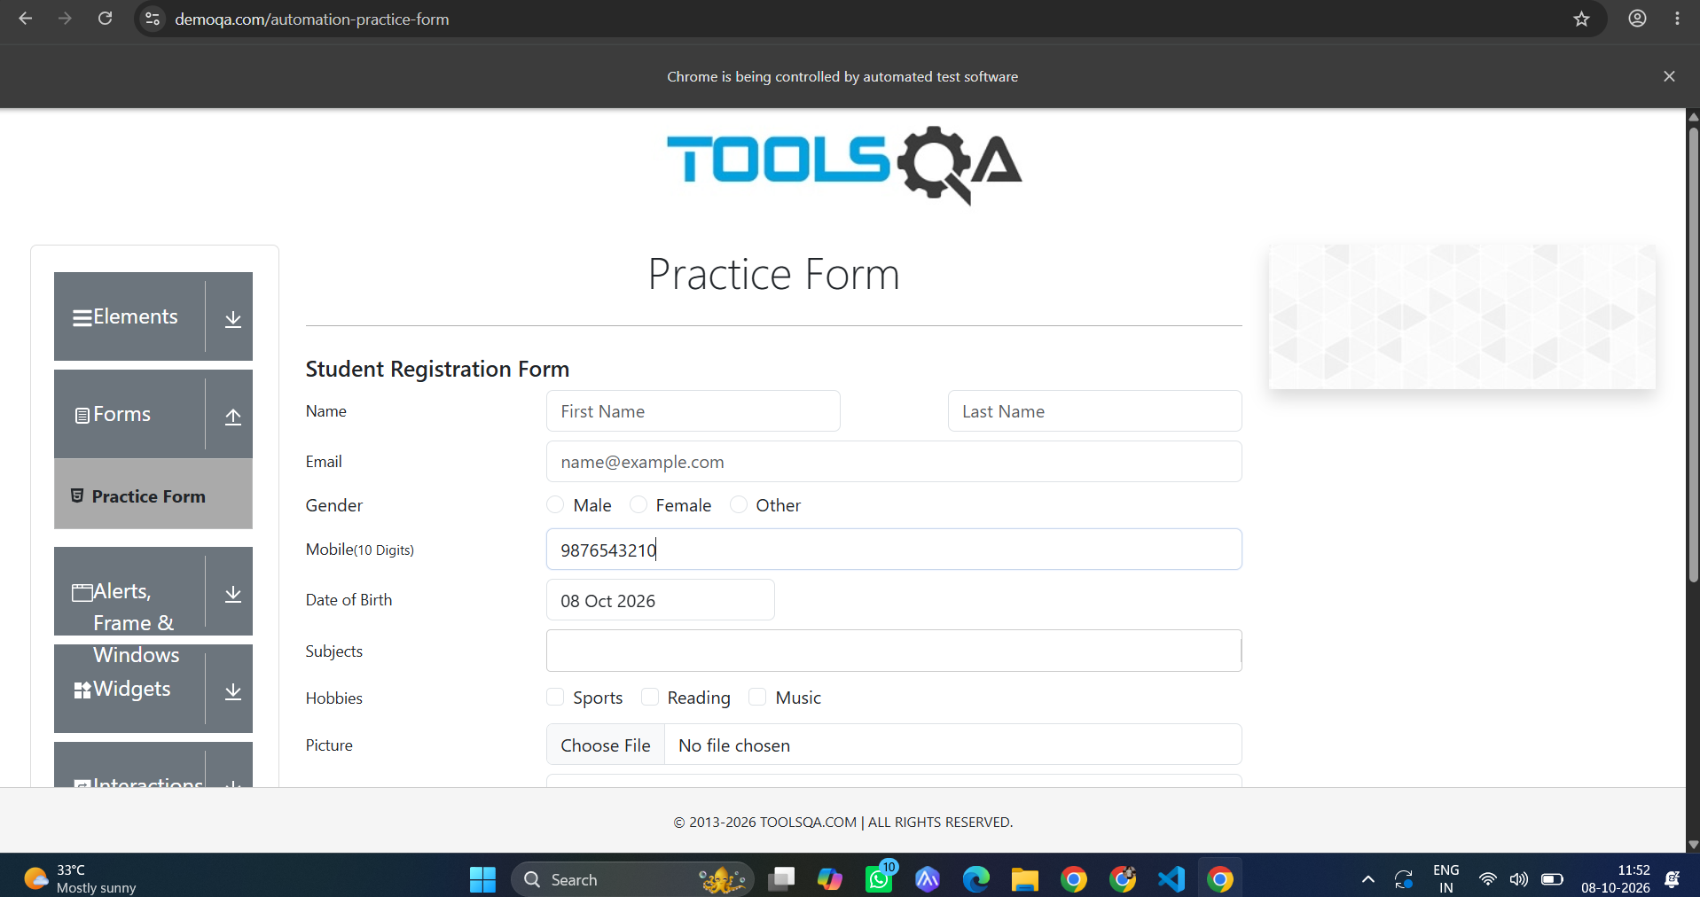

Task-6:
Code:
import time
from selenium import webdriver
from selenium.webdriver.common.by import By
from selenium.webdriver.support.ui import WebDriverWait
from selenium.webdriver.support import expected_conditions as EC

driver = webdriver.Chrome()
wait = WebDriverWait(driver, 10)

# Open page
driver.get("https://demoqa.com/automation-practice-form")
time.sleep(3)

# TC06: Locate element using starts-with() prefix matching
# Matches <input id="userNumber"> or <input id="userEmail"> starting with 'user'
mobile_input = wait.until(
EC.visibility_of_element_located((By.XPATH, "//input[starts-with(@id, 'userN')]"))
)
mobile_input.send_keys("9876543210")
time.sleep(2)

print("✓ TC06 Passed: Element located using starts-with() XPath")

Output:

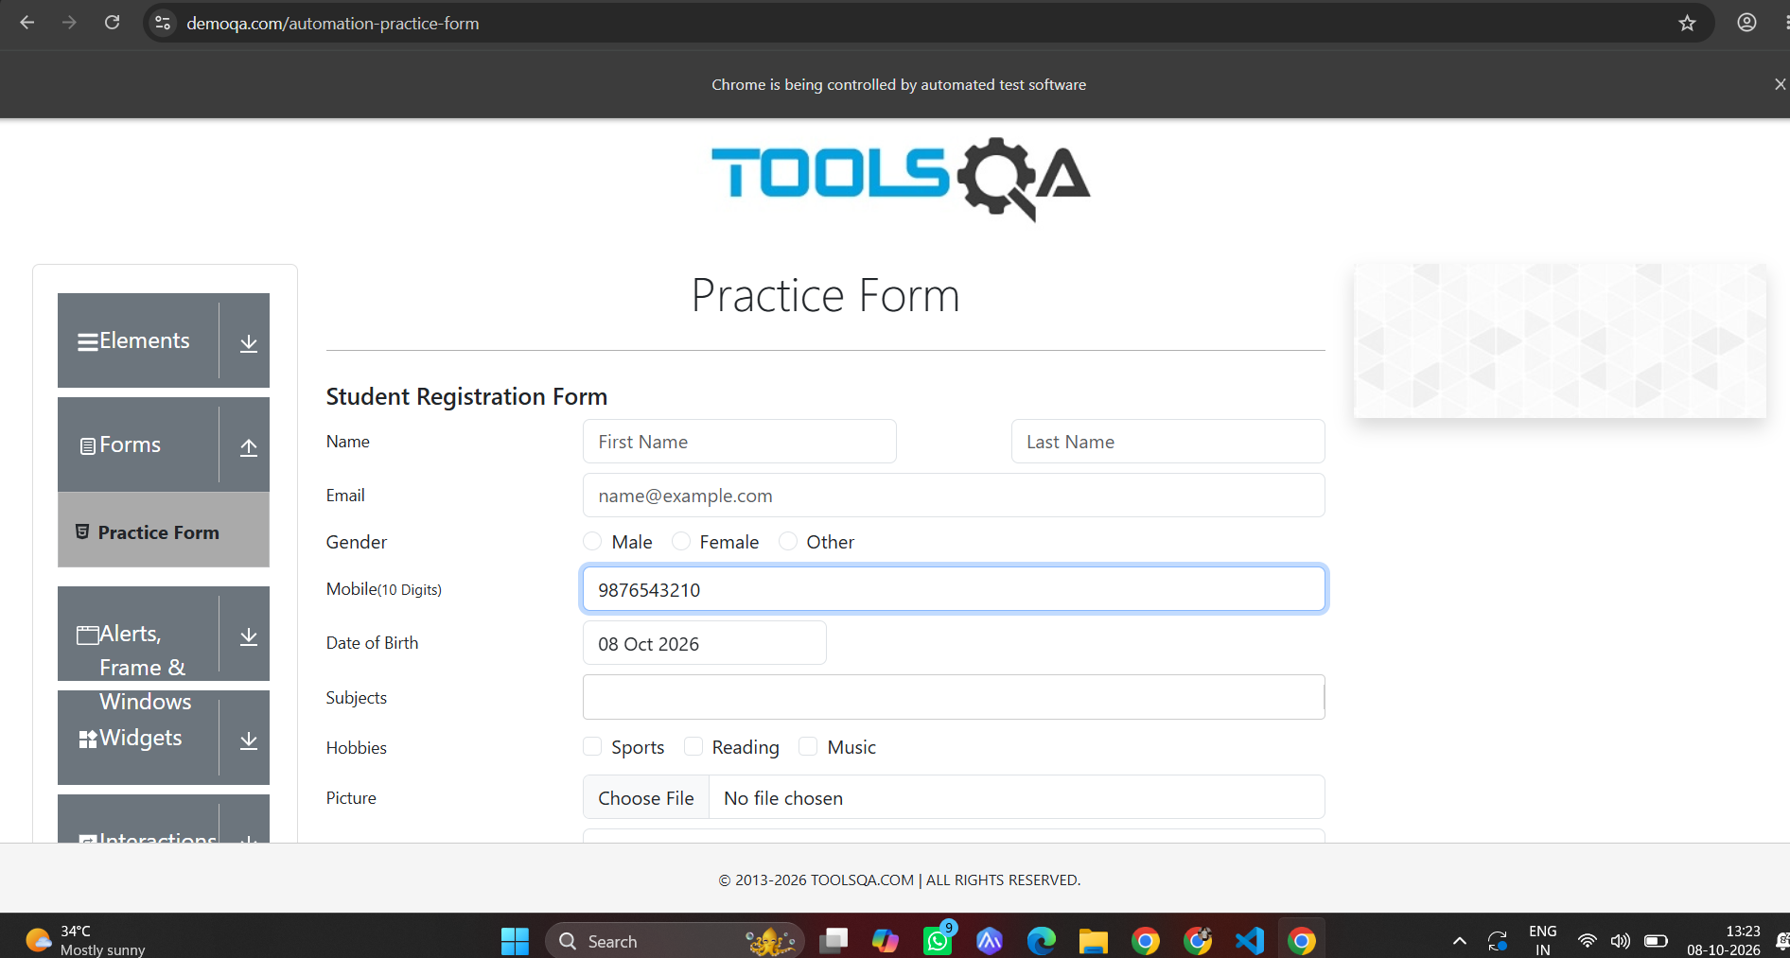

Task-07:
Code:
import time
from selenium import webdriver
from selenium.webdriver.common.by import By
from selenium.webdriver.support.ui import WebDriverWait
from selenium.webdriver.support import expected_conditions as EC

driver = webdriver.Chrome()
wait = WebDriverWait(driver, 10)

# Open page
driver.get("https://demoqa.com/automation-practice-form")
time.sleep(3)

# TC07: Locate input using TWO attributes with 'and'
# Matches <input id="userEmail" type="text">
email_field = wait.until(
EC.visibility_of_element_located((By.XPATH, "//input[@id='userEmail' and @type='text']"))
)
email_field.send_keys("teststudent@example.com")
time.sleep(4)

print("✓ TC07 Passed: Input located using two attributes with 'and'")

Output:
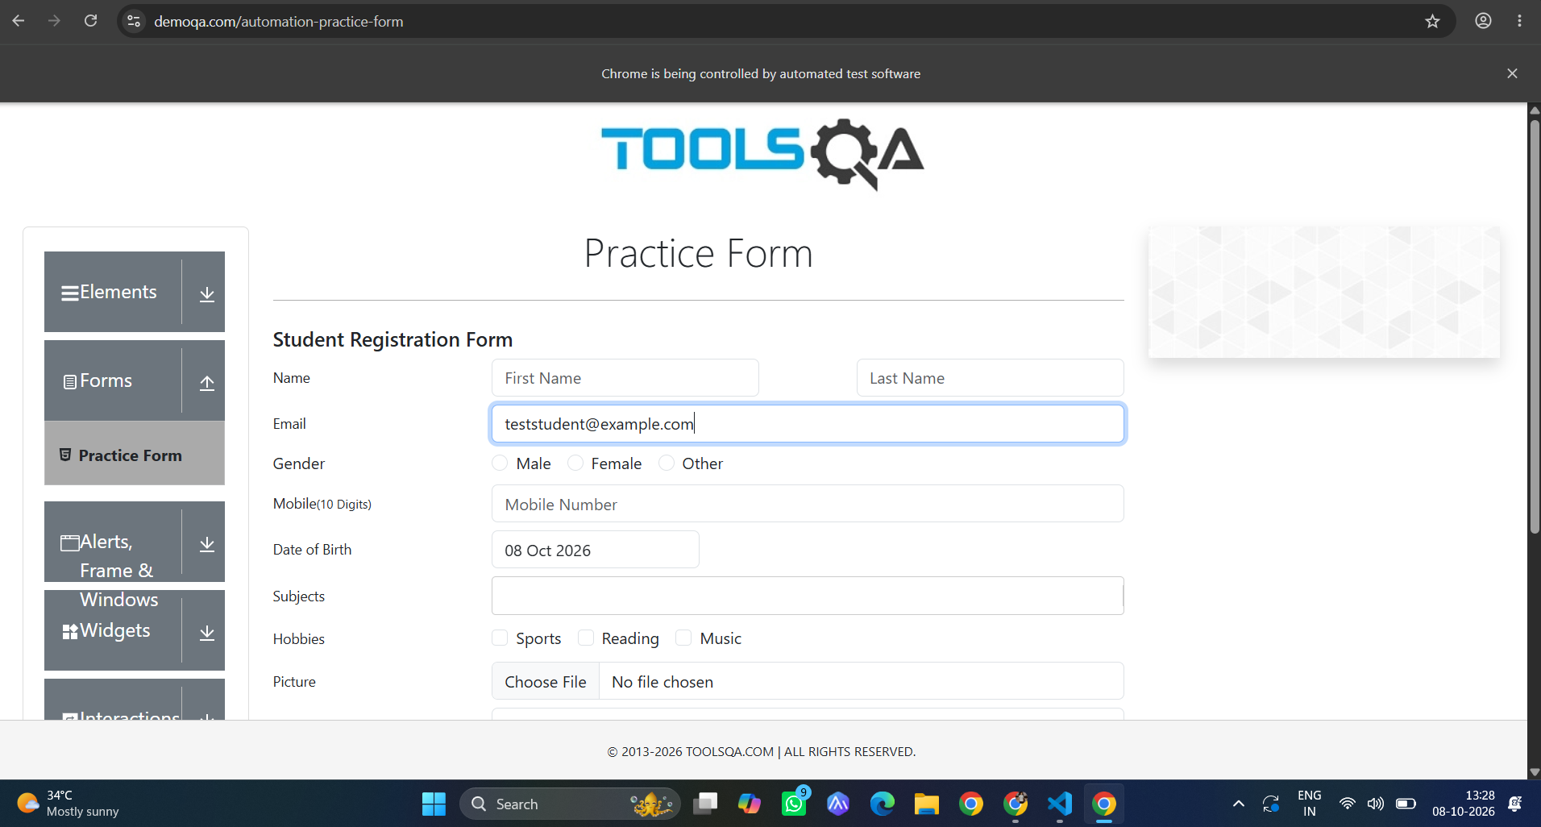
Task-8:
Code:
import time
from selenium import webdriver
from selenium.webdriver.common.by import By
from selenium.webdriver.support.ui import WebDriverWait
from selenium.webdriver.support import expected_conditions as EC

driver = webdriver.Chrome()
wait = WebDriverWait(driver, 10)

# Open page
driver.get("https://demoqa.com/automation-practice-form")
time.sleep(3)

# TC08: Locate element using alternatives with 'or'
# Matches element if EITHER @id='userName' OR @id='firstName' is true
first_name = wait.until(
EC.visibility_of_element_located((By.XPATH, "//input[@id='userName' or @id='firstName']"))
)
first_name.send_keys("Swaminathan")
time.sleep(2)

print("✓ TC08 Passed: Element located using 'or' alternative XPath")

Output:
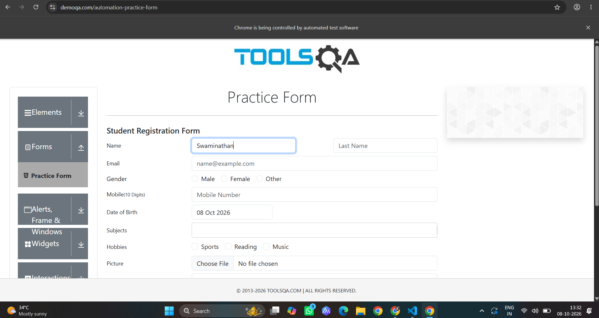
Task-09:
Code:
import time
from selenium import webdriver
from selenium.webdriver.common.by import By
from selenium.webdriver.support.ui import WebDriverWait
from selenium.webdriver.support import expected_conditions as EC

driver = webdriver.Chrome()
wait = WebDriverWait(driver, 10)

# Open page
driver.get("https://demoqa.com/automation-practice-form")
time.sleep(3)

# TC09: Locate the parent <form> element using the parent / ancestor axis
# Starts from an input field and navigates up to the parent form (#userForm)
user_form = wait.until(
EC.presence_of_element_located((By.XPATH, "//input[@id='firstName']/ancestor::form[@id='userForm']"))
)
time.sleep(2)

print("✓ TC09 Passed: Parent form located!")
print(f" Tag Name : {user_form.tag_name}")
print(f" Form ID : {user_form.get_attribute('id')}")

Output:
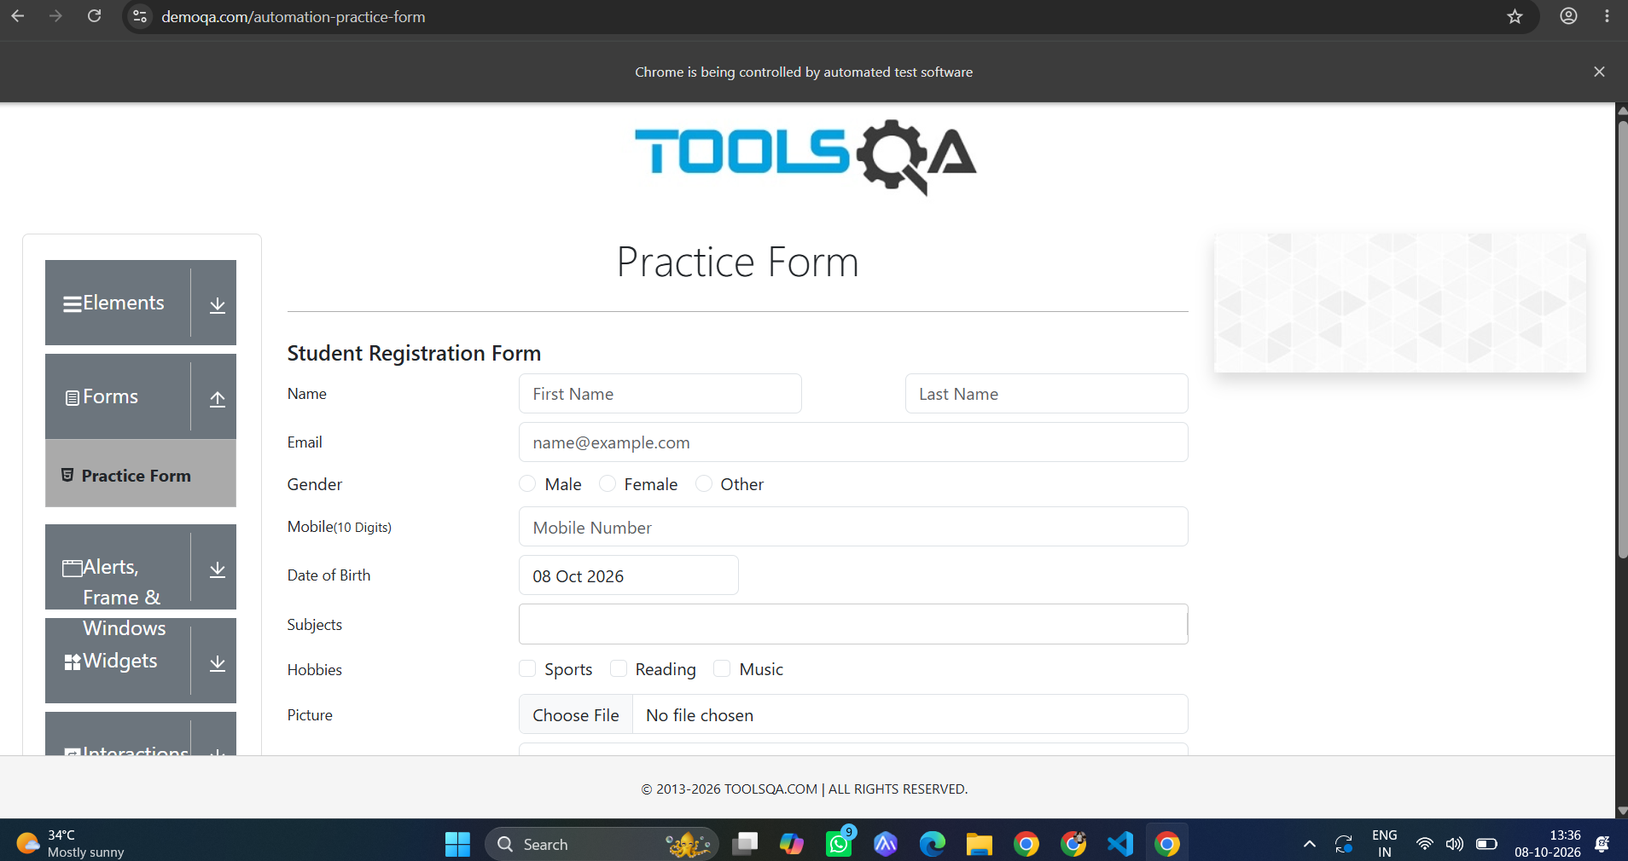

Task 10:
Code:
import time
from selenium import webdriver
from selenium.webdriver.common.by import By
from selenium.webdriver.support import expected_conditions as EC
from selenium.webdriver.support.ui import WebDriverWait

driver = webdriver.Chrome()
wait = WebDriverWait(driver, 10)

# Open page
driver.get("https://demoqa.com/automation-practice-form")
time.sleep(3)

# TC10: Locate the enclosing <form> using the 'ancestor' axis starting from <input>
# Syntax: //tag[conditions]/ancestor::target_tag
form_element = wait.until(
EC.presence_of_element_located((
By.XPATH,
"//input[@id='firstName']/ancestor::form[@id='userForm']",
))
)
time.sleep(2)

print("✓ TC10 Passed: Form located from input using ancestor axis!")
print(f" Tag Name : {form_element.tag_name}")
print(f" Form ID : {form_element.get_attribute('id')}")

Output:

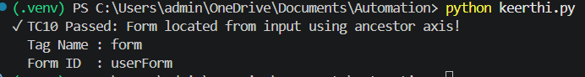
Task 11:
Code:
from selenium import webdriver
from selenium.webdriver.chrome.options import Options
from selenium.webdriver.common.by import By

chrome_options = Options()
chrome_options.add_experimental_option("detach", True)

driver = webdriver.Chrome(options=chrome_options)
driver.get("https://www.tutorialspoint.com/selenium/practice/login.php")

child_inputs = driver.find_elements(By.XPATH, "//form//input")
print(len(child_inputs))

Output:
Task 12:
Code:
import time
from selenium import webdriver
from selenium.webdriver.common.by import By
from selenium.webdriver.support import expected_conditions as EC
from selenium.webdriver.support.ui import WebDriverWait

driver = webdriver.Chrome()
wait = WebDriverWait(driver, 10)

# Open page
driver.get("https://demoqa.com/automation-practice-form")
time.sleep(3)

# TC12: Locate the next element using the following axis
# Starts at First Name and locates the following input element in document order (Last Name)
last_name = wait.until(
EC.visibility_of_element_located((
By.XPATH,
"//input[@id='firstName']/following::input[@id='lastName']",
))
)
last_name.send_keys("V")
time.sleep(2)

print("✓ TC12 Passed: Next element located using following axis")
print(f" Field Placeholder: {last_name.get_attribute('placeholder')}")

Output:
Task-13:
Code:
import time
from selenium import webdriver
from selenium.webdriver.common.by import By
from selenium.webdriver.support import expected_conditions as EC
from selenium.webdriver.support.ui import WebDriverWait

driver = webdriver.Chrome()
wait = WebDriverWait(driver, 10)

# Open page
driver.get("https://demoqa.com/automation-practice-form")
time.sleep(3)

# Scroll down slightly so the hobbies section is in view
driver.execute_script("window.scrollBy(0, 300);")
time.sleep(1)

# TC13: Locate Checkbox label using Attribute XPath [@for='hobbies-checkbox-1']
# (1 = Sports, 2 = Reading, 3 = Music)
sports_checkbox = wait.until(
EC.element_to_be_clickable((By.XPATH, "//label[@for='hobbies-checkbox-1']"))
)
sports_checkbox.click()
time.sleep(2)

print("✓ TC13 Passed: Checkbox located and checked using Attribute XPath")

Output:
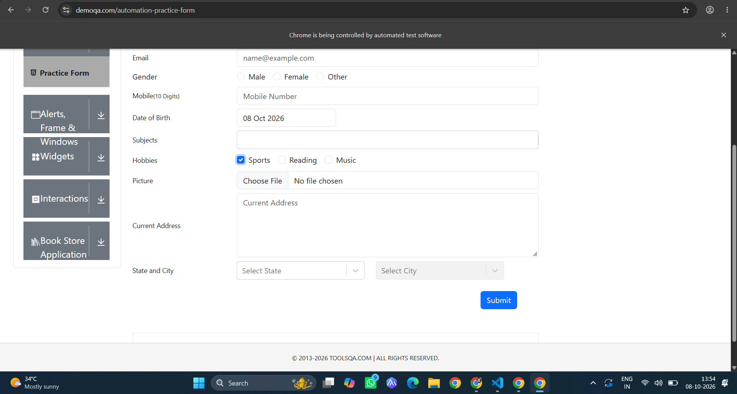
Task-14:
Code:
import time
from selenium import webdriver
from selenium.webdriver.common.by import By
from selenium.webdriver.support import expected_conditions as EC
from selenium.webdriver.support.ui import WebDriverWait

driver = webdriver.Chrome()
wait = WebDriverWait(driver, 10)

# Open page
driver.get("https://demoqa.com/automation-practice-form")
time.sleep(3)

# TC14: Locate Radio Button using Attribute XPath
# Option 1: Click the visible <label> via @for attribute matching the radio input ID
male_radio_label = wait.until(
EC.element_to_be_clickable((By.XPATH, "//label[@for='gender-radio-1']"))
)
male_radio_label.click()
time.sleep(2)

print("✓ TC14 Passed: Radio button selected using Attribute XPath")

Output:
Task-15:
Code:
import time
from selenium import webdriver
from selenium.webdriver.common.by import By
from selenium.webdriver.support import expected_conditions as EC
from selenium.webdriver.support.ui import Select, WebDriverWait

driver = webdriver.Chrome()
wait = WebDriverWait(driver, 10)

# Open page
driver.get("https://demoqa.com/automation-practice-form")
time.sleep(3)

# 1. Click the Date of Birth input field to open the calendar pop-up
dob_input = wait.until(
EC.element_to_be_clickable((By.XPATH, "//input[@id='dateOfBirthInput']"))
)
dob_input.click()
time.sleep(1)

# 2. TC15: Locate dropdown using XPath and wrap with Selenium's Select class
# Locate Month dropdown: <select class="react-datepicker__month-select">
month_dropdown_element = wait.until(
EC.presence_of_element_located(
(By.XPATH, "//select[@class='react-datepicker__month-select']")
)
)
month_select = Select(month_dropdown_element)
month_select.select_by_visible_text("May") # Select month by visible text
time.sleep(2)

# Locate Year dropdown: <select class="react-datepicker__year-select">
year_dropdown_element = driver.find_element(
By.XPATH, "//select[@class='react-datepicker__year-select']"
)
year_select = Select(year_dropdown_element)
year_select.select_by_value("2004") # Select year by attribute value
time.sleep(2)

# Pick day '15' to finish selection
day_15 = driver.find_element(
By.XPATH,
"//div[contains(@class,'react-datepicker__day--015') and not(contains(@class,'--outside-month'))]",
)
day_15.click()
time.sleep(2)

print("✓ TC15 Passed: Dropdown selected using XPath + Select class")

Output:
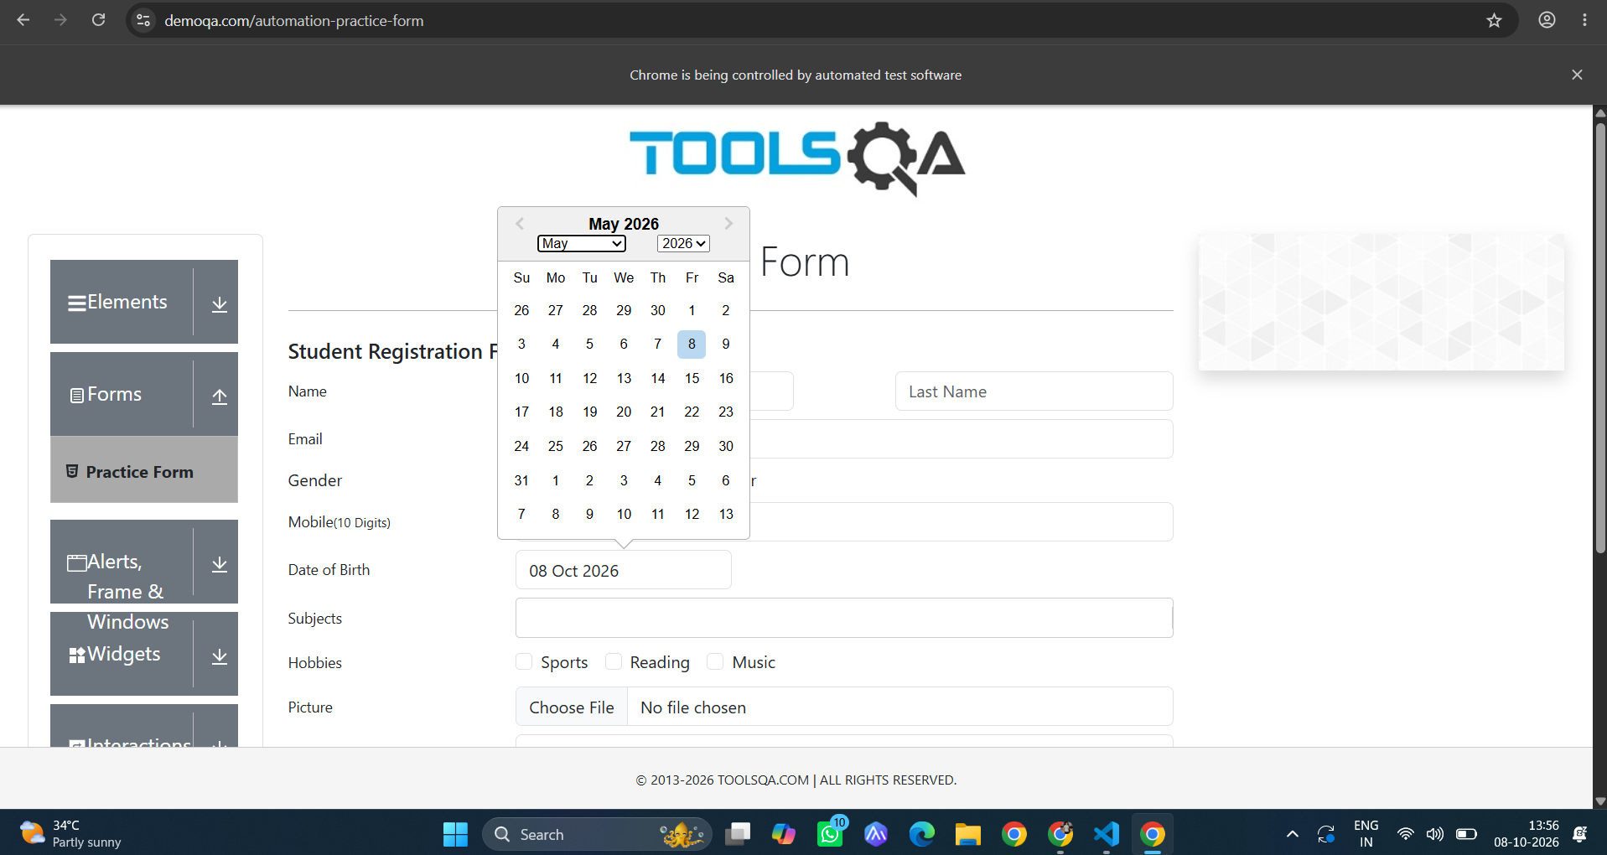
Task-16:
Code:
import time
from selenium import webdriver
from selenium.webdriver.common.by import By
from selenium.webdriver.support import expected_conditions as EC
from selenium.webdriver.support.ui import WebDriverWait

driver = webdriver.Chrome()
wait = WebDriverWait(driver, 10)

# Open page
driver.get("https://demoqa.com/automation-practice-form")
time.sleep(3)

# TC16: Locate the second text input box using an XPath index [2]
# Wrapping the general locator in parentheses creates a node-set, then [2] picks the 2nd one
second_textbox = wait.until(
EC.visibility_of_element_located((
By.XPATH,
"(//input[@type='text'])[2]",
))
)
second_textbox.send_keys("V")
time.sleep(2)

print("✓ TC16 Passed: Second textbox located using XPath index [2]")
print(f" Field ID: {second_textbox.get_attribute('id')}")
print(f" Placeholder: {second_textbox.get_attribute('placeholder')}")

Output:
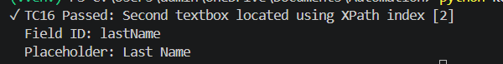
Task-17:
Code:
import time
from selenium import webdriver
from selenium.webdriver.common.by import By
from selenium.webdriver.support import expected_conditions as EC
from selenium.webdriver.support.ui import WebDriverWait

driver = webdriver.Chrome()
wait = WebDriverWait(driver, 10)

# Open page
driver.get("https://demoqa.com/automation-practice-form")
time.sleep(3)

# 1. Fill mandatory fields to trigger the modal
wait.until(
EC.visibility_of_element_located((By.XPATH, "//input[@id='firstName']"))
).send_keys("Swaminathan")

driver.find_element(By.XPATH, "//input[@id='lastName']").send_keys("V")
driver.find_element(By.XPATH, "//input[@id='userNumber']").send_keys("9876543210")

# Select Gender radio label
driver.find_element(By.XPATH, "//label[@for='gender-radio-1']").click()
time.sleep(1)

# 2. Click Submit
submit_btn = driver.find_element(By.XPATH, "//button[@id='submit']")
driver.execute_script("arguments[0].scrollIntoView(true);", submit_btn)
driver.execute_script("arguments[0].click();", submit_btn)
time.sleep(2)

# TC17: Locate and verify submitted confirmation message using text()
# HTML: <div class="modal-title h4" id="example-modal-sizes-title-lg">Thanks for submitting the form</div>
success_message = wait.until(
EC.visibility_of_element_located((
By.XPATH,
"//div[text()='Thanks for submitting the form']",
))
)
time.sleep(2)

# Verification check
expected_text = "Thanks for submitting the form"
actual_text = success_message.text.strip()
assert actual_text == expected_text, f"Expected '{expected_text}', got '{actual_text}'"

print("✓ TC17 Passed: Submission message verified using text() XPath!")
print(f" Verified Message: '{actual_text}'")

Output:
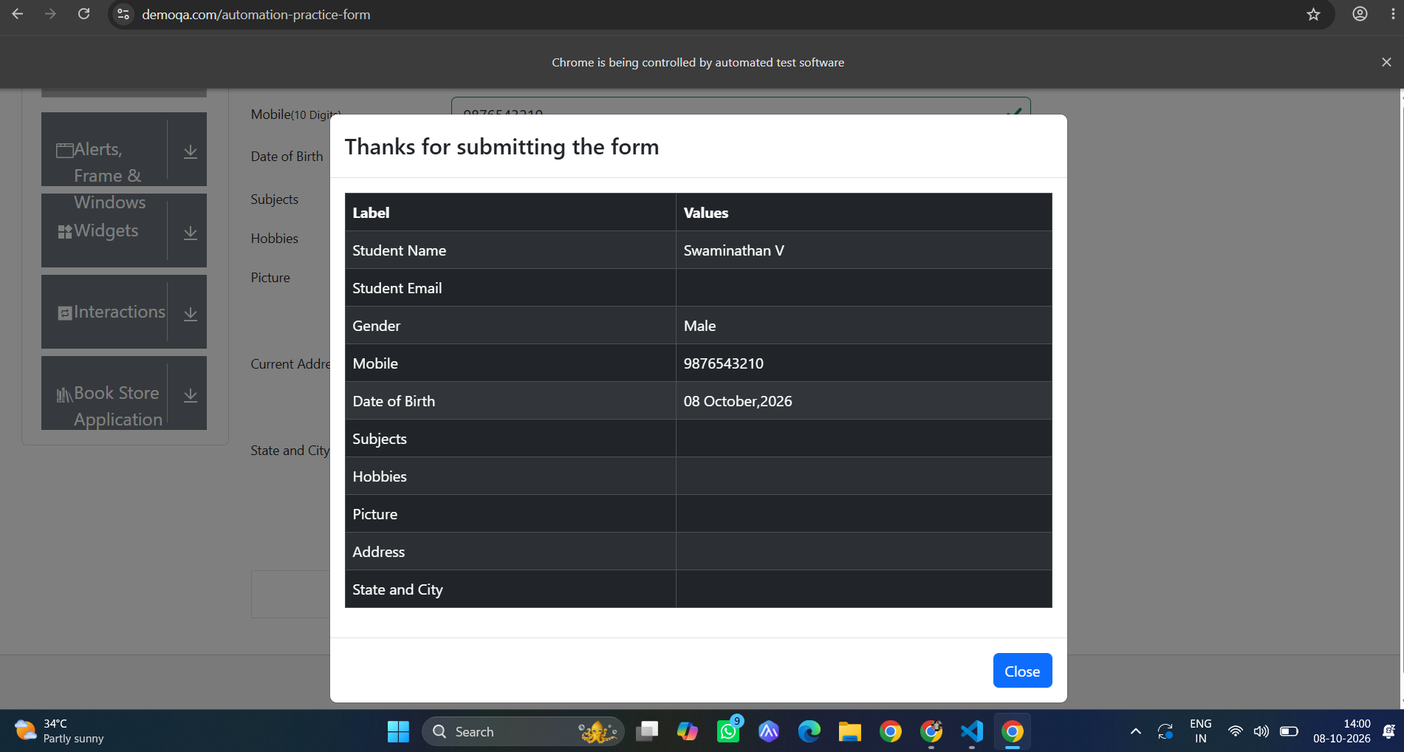
Task-18:
Code:
import time
from selenium import webdriver
from selenium.webdriver.common.by import By
from selenium.webdriver.support import expected_conditions as EC
from selenium.webdriver.support.ui import WebDriverWait

driver = webdriver.Chrome()
wait = WebDriverWait(driver, 10)

# Open page
driver.get("https://demoqa.com/automation-practice-form")
time.sleep(3)

# Ensure the form is loaded
wait.until(
EC.presence_of_element_located((By.XPATH, "//form[@id='userForm']"))
)

# TC18: Locate all input fields using find_elements() with XPath
# Finds every <input> tag inside the form
all_inputs = driver.find_elements(By.XPATH, "//form[@id='userForm']//input")
time.sleep(2)

print(f"✓ TC18 Passed: Found {len(all_inputs)} input fields using find_elements()")
print("-" * 50)

# Iterate and display details for each input element
for index, element in enumerate(all_inputs, start=1):
input_type = element.get_attribute("type") or "N/A"
input_id = element.get_attribute("id") or "N/A"
input_name = element.get_attribute("name") or "N/A"
placeholder = element.get_attribute("placeholder") or "N/A"
print(f"[{index:02d}] ID: {input_id:<20} | Type: {input_type:<10} | Placeholder: {placeholder}")

Output:
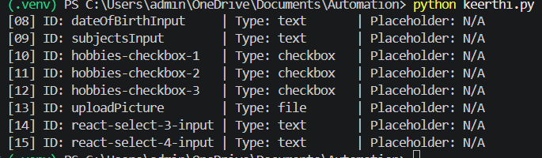
Task-19:
Code:
import time
from selenium import webdriver
from selenium.webdriver.common.by import By
from selenium.webdriver.support import expected_conditions as EC
from selenium.webdriver.support.ui import WebDriverWait

driver = webdriver.Chrome()
wait = WebDriverWait(driver, 10)

# Open page
driver.get("https://demoqa.com/automation-practice-form")
time.sleep(3)

# TC19: Locate a dynamic element using contains() on an attribute
# On dynamic pages where IDs or classes have generated prefixes/suffixes,
# contains() targets the stable portion of the string.
# Example: Matches <input id="userEmail"> via substring 'Email'
dynamic_email = wait.until(
EC.visibility_of_element_located((
By.XPATH,
"//input[contains(@id, 'Email')]",
))
)
dynamic_email.send_keys("swaminathan@example.com")
time.sleep(2)

# Another common dynamic example on DemoQA: Calendar day cells with dynamic class names
# HTML: <div class="react-datepicker__day react-datepicker__day--015 ...">
# XPath: //div[contains(@class, 'react-datepicker__day--015')]

print("✓ TC19 Passed: Dynamic element located using contains() XPath")
print(f" Located Element ID: {dynamic_email.get_attribute('id')}")

Output:
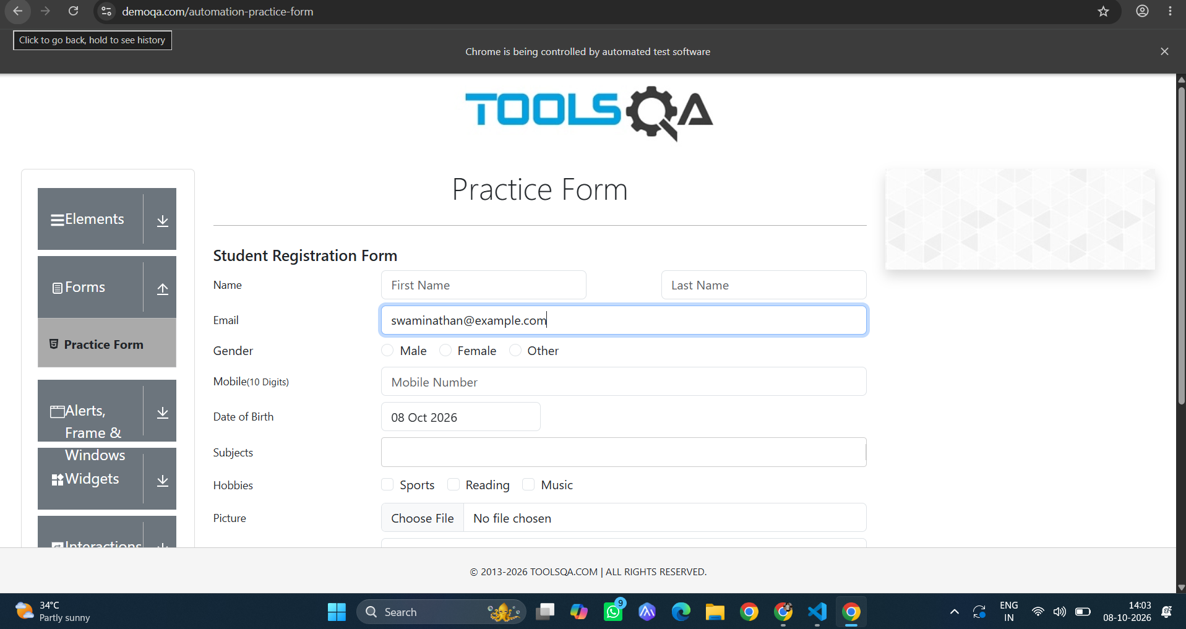
Task-20:
Code:
import os
import time
from selenium import webdriver
from selenium.webdriver.common.by import By
from selenium.webdriver.common.keys import Keys
from selenium.webdriver.support import expected_conditions as EC
from selenium.webdriver.support.ui import Select, WebDriverWait

driver = webdriver.Chrome()
driver.maximize_window()
wait = WebDriverWait(driver, 10)

try:
# 1. Open DemoQA Practice Form
driver.get("https://demoqa.com/automation-practice-form")
time.sleep(2)

# 2. First Name: starts-with() XPath
first_name = wait.until(
EC.visibility_of_element_located(
(By.XPATH, "//input[starts-with(@id, 'firstN')]")
)
)
first_name.send_keys("Swaminathan")

# 3. Last Name: XPath following axis
last_name = driver.find_element(
By.XPATH, "//input[@id='firstName']/following::input[@id='lastName']"
)
last_name.send_keys("V")

# 4. Email: contains() XPath
email = driver.find_element(
By.XPATH, "//input[contains(@id, 'userEmail')]"
)
email.send_keys("swaminathan@example.com")

# 5. Gender: Attribute XPath targeting label
male_radio = driver.find_element(
By.XPATH, "//label[@for='gender-radio-1']"
)
male_radio.click()

# 6. Mobile: Logical 'and' with two attributes
mobile = driver.find_element(
By.XPATH, "//input[@id='userNumber' and @type='text']"
)
mobile.send_keys("9876543210")

# 7. Date of Birth: XPath + Select class
dob_field = driver.find_element(
By.XPATH, "//input[@id='dateOfBirthInput']"
)
dob_field.click()
time.sleep(1)

# Month Select
month_dropdown = driver.find_element(
By.XPATH, "//select[@class='react-datepicker__month-select']"
)
Select(month_dropdown).select_by_visible_text("May")

# Year Select
year_dropdown = driver.find_element(
By.XPATH, "//select[@class='react-datepicker__year-select']"
)
Select(year_dropdown).select_by_value("2004")

# Day selection using contains() class
day_cell = driver.find_element(
By.XPATH,
"//div[contains(@class, 'react-datepicker__day--015') and not(contains(@class, 'outside-month'))]",
)
day_cell.click()

# 8. Subjects: Dynamic input using text() context and ancestor axis
subjects_input = driver.find_element(
By.XPATH,
"//label[text()='Subjects']/ancestor::div[@id='subjects-wrapper']//input",
)
subjects_input.send_keys("Computer Science")
subjects_input.send_keys(Keys.ENTER)

# 9. Hobbies: Alternative 'or' condition on labels
hobby_checkbox = driver.find_element(
By.XPATH,
"//label[@for='hobbies-checkbox-1' or @for='hobbies-checkbox-2']",
)
driver.execute_script("arguments[0].click();", hobby_checkbox)

# 10. Current Address: Textarea via Attribute XPath
address = driver.find_element(
By.XPATH, "//textarea[@id='currentAddress']"
)
address.send_keys("Saveetha Engineering College, Chennai, Tamil Nadu")

# 11. State & City: Custom React dropdowns via XPath descendant axis
driver.execute_script("window.scrollBy(0, 300);")
time.sleep(1)

# Open State dropdown
state_box = driver.find_element(
By.XPATH, "//div[@id='state']//input"
)
state_box.send_keys("NCR")
state_box.send_keys(Keys.ENTER)
time.sleep(1)

# Open City dropdown
city_box = driver.find_element(
By.XPATH, "//div[@id='city']//input"
)
city_box.send_keys("Delhi")
city_box.send_keys(Keys.ENTER)
time.sleep(1)

# 12. Submit Button: text() XPath
submit_btn = driver.find_element(
By.XPATH, "//button[text()='Submit']"
)
driver.execute_script("arguments[0].click();", submit_btn)

# 13. Verify Modal: Modal verification using text() & ancestor/descendant inspection
modal_title = wait.until(
EC.visibility_of_element_located(
(By.XPATH, "//div[text()='Thanks for submitting the form']")
)
)
print("✓ Modal displayed:", modal_title.text)

# Retrieve all submission table rows using find_elements()
table_rows = driver.find_elements(
By.XPATH, "//div[@class='table-responsive']//tbody/tr"
)
print("\n--- Submitted Data Summary ---")
for row in table_rows:
label = row.find_element(By.XPATH, "./td[1]").text
value = row.find_element(By.XPATH, "./td[2]").text
print(f"{label:<20} : {value}")

print("\n✓ TC20 Passed: Complete Registration Suite executed successfully!")

finally:
time.sleep(4)
driver.quit()

Output:
